**⇒ Mandatory Hands-On**

**Exercise 1: Configuring a Basic Spring Application**

**Exercise 2: Implementing Dependency Injection**

LibraryManagement/pom.xml

**<project xmlns="http://maven.apache.org/POM/4.0.0" xmlns:xsi="http://www.w3.org/2001/XMLSchema-instance" xsi:schemaLocation="http://maven.apache.org/POM/4.0.0 http://maven.apache.org/xsd/maven-4.0.0.xsd">**

**<modelVersion>4.0.0</modelVersion>**

**<groupId>com.library</groupId>**

**<artifactId>LibraryManagement</artifactId>**

**<version>0.0.1-SNAPSHOT</version>**

**<dependencies>**

**<!-- Spring Core -->**

**<dependency>**

**<groupId>org.springframework</groupId>**

**<artifactId>spring-context</artifactId>**

**<version>5.3.33</version>**

**</dependency>**

**</dependencies>**

**</project>**

src/main/java/com.library.repository/BookRepository.java

**package com.library.repository;**

**public class BookRepository {**

**public void saveBook(String title) {**

**System.*out*.println("Book '" + title + "' saved to the database.");**

**}**

**}**

src/main/java/com.library.service/BookService.java

**package com.library.service;**

**import com.library.repository.BookRepository;**

**public class BookService {**

**private BookRepository bookRepository;**

**public void setBookRepository(BookRepository bookRepository) {**

**this.bookRepository = bookRepository;**

**}**

**public void addBook(String title) {**

**bookRepository.saveBook(title);**

**}**

**}**

src/main/java/LibraryManagementApplication.java

**package com.library;**

**import org.springframework.context.ApplicationContext;**

**import org.springframework.context.support.ClassPathXmlApplicationContext;**

**import com.library.service.BookService;**

**public class LibraryManagementApplication {**

**public static void main(String[] args) {**

**ApplicationContext context =**

**new ClassPathXmlApplicationContext("applicationContext.xml");**

**BookService service = context.getBean("bookService", BookService.class);**

**service.addBook("Spring in Action");**

**}**

**}**

**Result:**

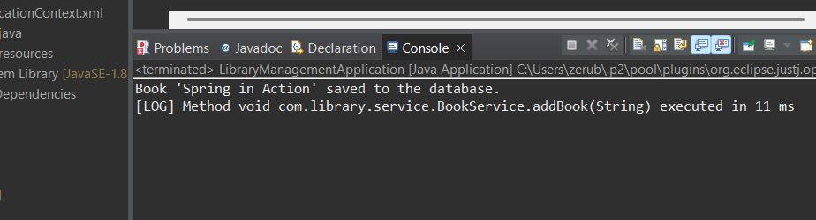

**Exercise 4: Creating and Configuring a Maven Project**

LibraryManagement/pom.xml

**<project xmlns="http://maven.apache.org/POM/4.0.0" xmlns:xsi="http://www.w3.org/2001/XMLSchema-instance" xsi:schemaLocation="http://maven.apache.org/POM/4.0.0 http://maven.apache.org/xsd/maven-4.0.0.xsd">**

**<modelVersion>4.0.0</modelVersion>**

**<groupId>com.library</groupId>**

**<artifactId>Library_Management</artifactId>**

**<version>0.0.1-SNAPSHOT</version>**

**<dependencies>**

**<!-- Spring Core -->**

**<dependency>**

**<groupId>org.springframework</groupId>**

**<artifactId>spring-context</artifactId>**

**<version>5.3.33</version>**

**</dependency>**

**<!-- Spring AOP -->**

**<dependency>**

**<groupId>org.springframework</groupId>**

**<artifactId>spring-aspects</artifactId>**

**<version>5.3.33</version>**

**</dependency>**

**<!-- Spring Web MVC -->**

**<dependency>**

**<groupId>org.springframework</groupId>**

**<artifactId>spring-webmvc</artifactId>**

**<version>5.3.33</version>**

**</dependency>**

**</dependencies>**

**<build>**

**<plugins>**

**<!-- Maven Compiler Plugin -->**

**<plugin>**

**<groupId>org.apache.maven.plugins</groupId>**

**<artifactId>maven-compiler-plugin</artifactId>**

**<version>3.8.1</version>**

**<configuration>**

**<source>1.8</source>**

**<target>1.8</target>**

**</configuration>**

**</plugin>**

**</plugins>**

**</build>**

**</project>**

**Result:**

